10-10-2026

CO1 -ASSSESMENT TOOL 1

APPLICATION BASED QUESTIONS

COURSE NAME: NATURAL LANGUAGE PROCESSING

COURSECODE: DSA0308

NAME:BODDU RAMYA REG.NO: 192424183

Session A: Resume Information Extraction Using Regular Expressions in Python

- Importing the Regular Expression Module: The statement import re imports Python's regular expression module. It provides functions such as re.search() and re.findall() to extract information from resume text.

- Storing the Resume Details: A multiline string is created using resume = """...""" to store the candidate's name, email address, mobile number, technical skills, and experience.

- Extracting the Candidate's Name: The statement re.search(r"Name:\s*(.+)", resume) searches for the candidate's name after the label Name:. The pattern \s* allows optional spaces, and (.+) captures the name. The group(1) method retrieves the captured name.

- Extracting the Email Address: The function re.findall(r'[\w.+-]+@[\w.-]+\.[A-Za-z]{2,}', resume) identifies email addresses. The pattern checks for the username, @ symbol, domain name, and extension. The findall() function can return multiple email addresses.

- Extracting the Mobile Number: The statement re.findall(r'\b\d{10}\b', resume) extracts mobile numbers containing exactly ten digits. Here, \d represents a digit, {10} specifies ten digits, and \b identifies word boundaries.
- Defining the Technical Skills: A list containing Python, Java, SQL, Machine Learning, and NLP is created. These are the technical skills that the system must identify in the resume.

- Detecting Technical Skills: A for loop checks each skill using re.search(). The re.IGNORECASE flag allows the program to recognize skills regardless of uppercase or lowercase letters. If a skill is found, skills.append(skill) adds it to the list. The re.escape() function treats skill names as literal text during matching.

- Extracting Years of Experience: The statement re.search(r'(\d+)\s+years?\s+of\s+experience', resume, re.IGNORECASE) searches for the candidate's years of experience. The pattern (\d+) captures the number, while years? matches both year and years.

- Converting Experience into a Number: The expression int(experience_match.group(1)) converts the extracted experience into an integer. If no matching experience is found, the program assigns 0. This allows numerical comparison with the minimum requirement of two years.

- Generating the Structured Candidate Profile: The print() statements display the candidate's name, email address, mobile number, technical skills, and years of experience in an organized format. If an email address or mobile number is missing, the program displays Not found.

- Checking the Eligibility Criteria: The condition if experience >= 2 and "Python" in skills: checks whether the candidate has at least two years of experience and possesses Python skills. The and operator ensures that both conditions must be satisfied.

- Displaying the Final Result: The if-else statement displays the candidate's eligibility status. If both conditions are satisfied, the candidate is marked as eligible for shortlisting; otherwise, the candidate is marked as not eligible.

Program Code

import re
resume = """
Name: Rahul Sharma
Email: rahul.sharma@gmail.com
Mobile: 9876543210
Skills: Python, Java, SQL, Machine Learning, NLP
Experience: 3 years of experience
"""

name_match = re.search(r"Name:\s*(.+)", resume)
name = name_match.group(1).strip() if name_match else "Not found"

emails = re.findall(
r'[\w.+-]+@[\w.-]+\.[A-Za-z]{2,}', resume
)

mobile_numbers = re.findall(r'\b\d{10}\b', resume)

technical_skills = [
"Python", "Java", "SQL", "Machine Learning", "NLP"
]

skills = []for skill in technical_skills:
if re.search(re.escape(skill), resume, re.IGNORECASE):
skills.append(skill)

experience_match = re.search(
r'(\d+)\s+years?\s+of\s+experience',
resume,
re.IGNORECASE
)

experience = int(experience_match.group(1)) if experience_match else 0

print("----- Candidate Profile -----")
print("Name:", name)
print("Email:", ", ".join(emails) if emails else "Not found")
print("Mobile:", ", ".join(mobile_numbers) if mobile_numbers else "Not found")
print("Technical Skills:", ", ".join(skills) if skills else "None")
print("Experience:", experience, "years")

print("\n----- Eligibility Result -----")

if experience >= 2 and "Python" in skills:
print("Status: Eligible for shortlisting")
else:
print("Status: Not eligible for shortlisting")

Expected output:

----- Candidate Profile -----
Name: Rahul Sharma
Email: rahul.sharma@gmail.com
Mobile: 9876543210
Technical Skills: Python, Java, SQL, Machine Learning, NLP
Experience: 3 years

----- Eligibility Result -----
Status: Eligible for shortlisting
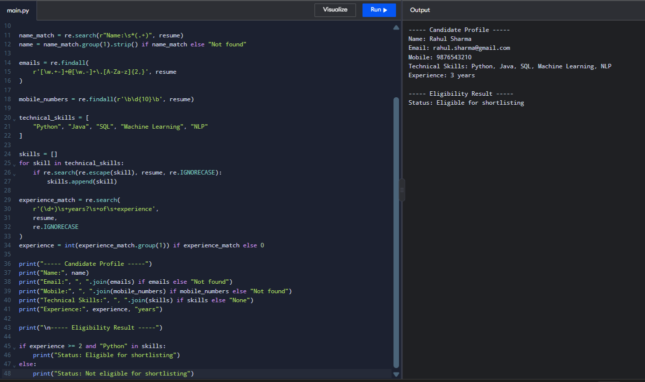

Session B: Product Search System Using Regular Expressions in Python
1. Importing the Regular Expression Module: The statement import re imports Python's regular expression module. It provides functions such as re.search() to search for product names using specific patterns.
2. Storing the Product Details: A list named products is created to store product names such as Apple iPhone, Samsung Mobile, Apple Laptop, Wireless Headphones, Gaming Laptop, and Mobile Charger.
3. Defining the Product Search Function: A function named search_products(pattern, search_type) is created to search products based on a given regular expression pattern and search type.
4. Performing Exact Keyword Search: The pattern r"\bMobile\b" searches for the exact word Mobile in product names. The \b symbol represents a word boundary, ensuring that the complete keyword is matched.
5. Performing Prefix-Based Search: The pattern r"^Apple" searches for product names that begin with Apple. The ^ symbol represents the beginning of a string.
6. Performing Suffix-Based Search: The pattern r"Laptop$" searches for product names that end with Laptop. The $ symbol represents the end of a string.
7. Performing Partial Keyword Search: The pattern r"phone" searches for product names containing the keyword phone anywhere in the name. This helps identify products containing a partial keyword.
8. Performing Case-Insensitive Search: The re.IGNORECASE flag allows the system to match keywords regardless of uppercase or lowercase letters. For example, sAmSuNg matches Samsung Mobile.
9. Extracting Matching Products: The list comprehension checks each product using re.search(). If a product matches the given pattern, it is added to the matches list.
10. Displaying Matching Product Names: The print() statements display the search type and all matching product names. If no product matches the search pattern, the system displays No products found.
11. Counting Matching Products: The statement len(matches) calculates the total number of products matching each search. This helps the company understand how many products are available for a particular keyword.
12. Generating the Search Report: The system performs exact keyword, prefix-based, suffix-based, partial-keyword, and case-insensitive searches. It displays all matching product names and the total number of matches for each search.

Program Code

import re

products = [
"Apple iPhone",
"Samsung Mobile",
"Apple Laptop",
"Wireless Headphones",
"Gaming Laptop",
"Mobile Charger"
]

def search_products(pattern, search_type):
matches = [
product for product in products
if re.search(pattern, product, re.IGNORECASE)
]

print("\n" + search_type)
if matches:
for product in matches:
print(product)
else:
print("No products found")

print("Total matches:", len(matches))

search_products(r"\bMobile\b", "Exact Keyword Search")

search_products(r"^Apple", "Prefix Search")

search_products(r"Laptop$", "Suffix Search")

search_products(r"phone", "Partial Keyword Search")

search_products(r"sAmSuNg", "Case-Insensitive Search")

Expected output:

Exact Keyword Search
Samsung Mobile
Mobile Charger
Total matches: 2

Prefix Search
Apple iPhone
Apple Laptop
Total matches: 2

Suffix Search
Apple Laptop
Gaming Laptop
Total matches: 2

Partial Keyword Search
Apple iPhone
Wireless Headphones
Total matches: 2

Case-Insensitive Search
Samsung Mobile
Total matches: 1

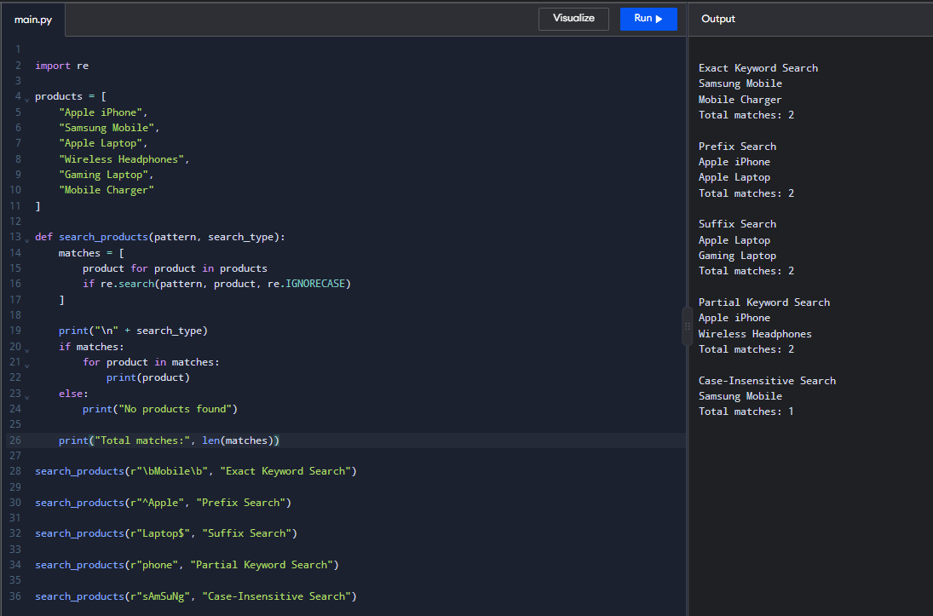

Session C: Student Registration Validation Using Regular Expressions in Python
1. Importing the Regular Expression Module: The statement import re imports Python's regular expression module. It provides the re.fullmatch() function to validate student information against specified patterns.
2. Storing Student Registration Details: Variables are created to store the student's register number, institutional email address, course code, semester information, and mobile number.
3. Validating the Student Register Number: The pattern r"\d{2}[A-Z]{2}\d{3}" validates the register number. Here, \d{2} represents two digits, [A-Z]{2} represents two uppercase letters, and \d{3} represents three digits.
4. Validating the Institutional Email Address: The pattern r"[\w.-]+@university\.edu" checks whether the email contains a valid username followed by @university.edu. The \. symbol represents a literal dot.
5. Validating the Course Code: The pattern r"[A-Z]{2}\d{3}" validates the course code. It requires two uppercase letters followed by three digits.
6. Validating the Semester Information: The pattern r"Semester [1-8]" checks whether the semester is between Semester 1 and Semester 8. The [1-8] expression matches a single digit from 1 to 8.
7. Validating the Student's Mobile Number: The pattern r"\d{10}" checks whether the mobile number contains exactly ten digits. The \d represents a digit, and {10} specifies ten digits.
8. Displaying Validation Messages: The if-else statements display appropriate messages for each field. If the information matches the specified pattern, the system displays Valid; otherwise, it displays Invalid.
9. Checking the Final Registration Status: The and operator checks whether all five fields satisfy their validation rules. The registration is successful only when every field is valid.
10. Generating the Registration Status Report: The program displays the validation results for all fields and generates a final report indicating Registration Successful or Registration Failed.

Program Code:

import re

register_no = "23CS101"
email = "student@university.edu"
course_code = "CS101"
semester = "Semester 3"
mobile = "9876543210"

if re.fullmatch(r"\d{2}[A-Z]{2}\d{3}", register_no):
print("Register Number: Valid")
else:
print("Register Number: Invalid")

if re.fullmatch(r"[\w.-]+@university\.edu", email):
print("Email Address: Valid")
else:
print("Email Address: Invalid")

if re.fullmatch(r"[A-Z]{2}\d{3}", course_code):
print("Course Code: Valid")
else:
print("Course Code: Invalid")

if re.fullmatch(r"Semester [1-8]", semester):
print("Semester: Valid")
else:
print("Semester: Invalid")

if re.fullmatch(r"\d{10}", mobile):
print("Mobile Number: Valid")
else:
print("Mobile Number: Invalid")

print("\n----- Registration Status Report -----")

if (re.fullmatch(r"\d{2}[A-Z]{2}\d{3}", register_no)
and re.fullmatch(r"[\w.-]+@university\.edu", email)
and re.fullmatch(r"[A-Z]{2}\d{3}", course_code)
and re.fullmatch(r"Semester [1-8]", semester)
and re.fullmatch(r"\d{10}", mobile)):
print("Registration Successful")
else:
print("Registration Failed")

Expected output:

Register Number: Valid
Email Address: Valid
Course Code: Valid
Semester: Valid
Mobile Number: Valid

----- Registration Status Report -----
Registration Successful

